Test Case: tc003_SPX_Dev5_Crear_Requisicion_Spot_Tipo_Cobro_CC_Urgent
Step 1 - Enter username and password and click to button Enter : Credentials Entered
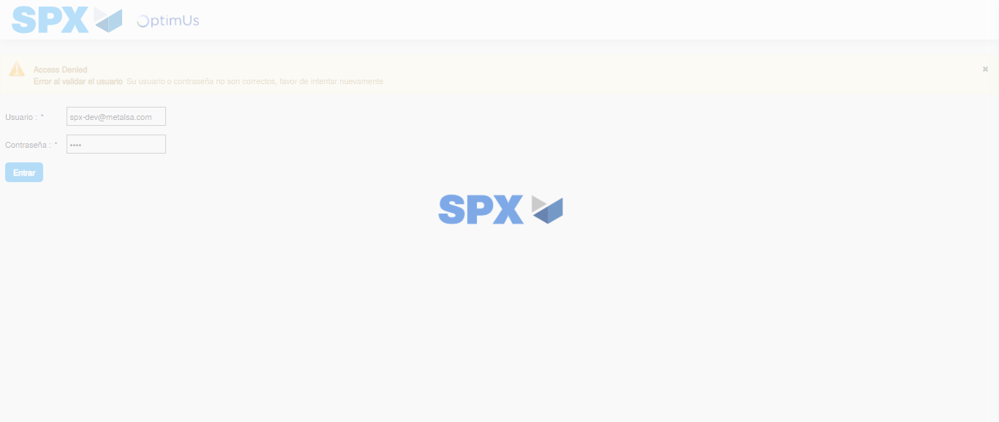Image file-name: QC_Testing-tc003_SPX_Dev5_Crear_Requisicion_Spot_Tipo_Cobro_CC_Urgent-1785961541228

Step 2 - Select to UEN and Access to Spot Buy Requisitions : UEN Correctly selected and Correct access
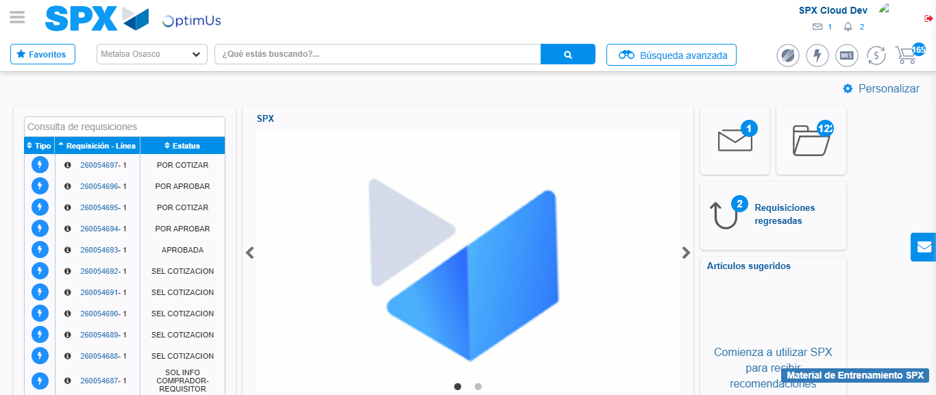Image file-name: QC_Testing-tc003_SPX_Dev5_Crear_Requisicion_Spot_Tipo_Cobro_CC_Urgent-1785961565786

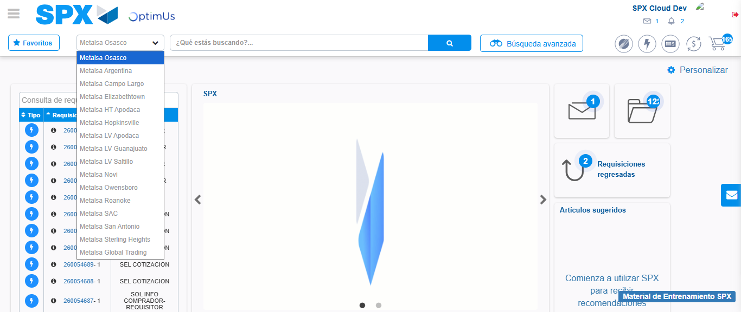Image file-name: QC_Testing-tc003_SPX_Dev5_Crear_Requisicion_Spot_Tipo_Cobro_CC_Urgent-1785961568392

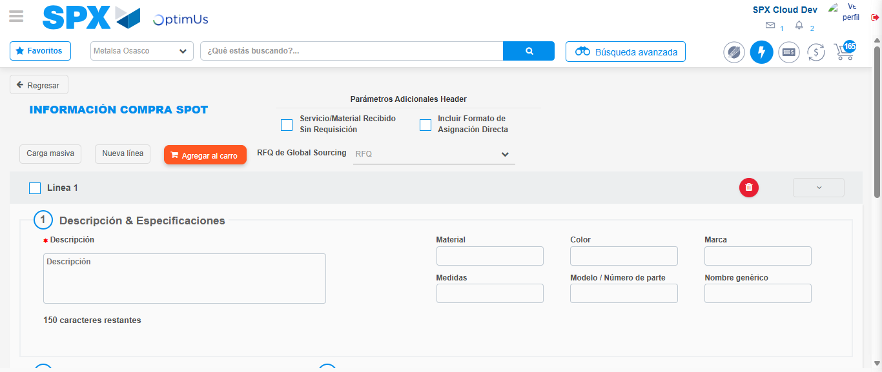Image file-name: QC_Testing-tc003_SPX_Dev5_Crear_Requisicion_Spot_Tipo_Cobro_CC_Urgent-1785961572564

Step 3 - Data Capture Spot Buy Requisition: Data captured correctly
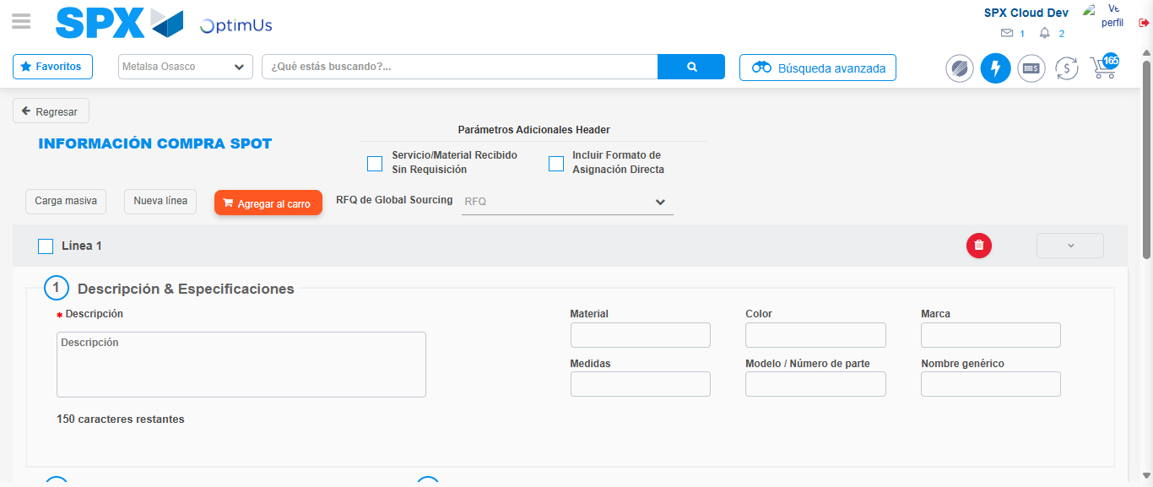Image file-name: QC_Testing-tc003_SPX_Dev5_Crear_Requisicion_Spot_Tipo_Cobro_CC_Urgent-1785961572838

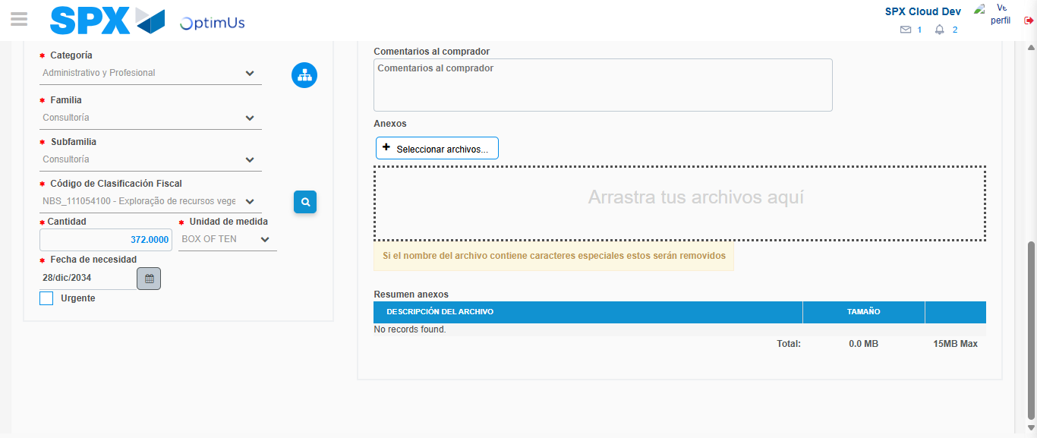Image file-name: QC_Testing-tc003_SPX_Dev5_Crear_Requisicion_Spot_Tipo_Cobro_CC_Urgent-1785961588704

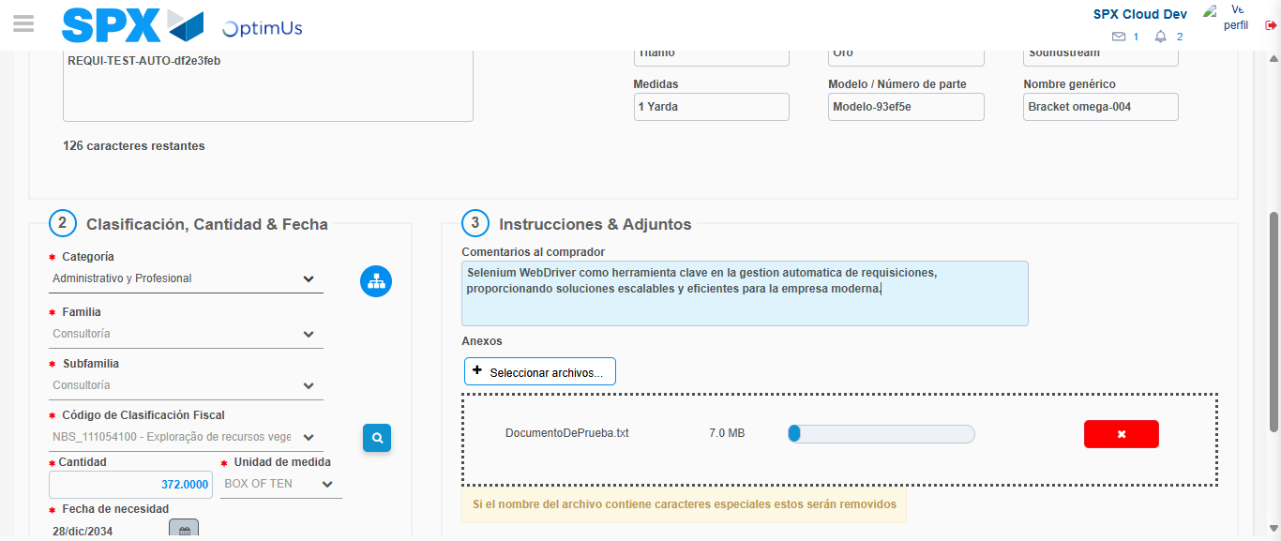Image file-name: QC_Testing-tc003_SPX_Dev5_Crear_Requisicion_Spot_Tipo_Cobro_CC_Urgent-1785961589423

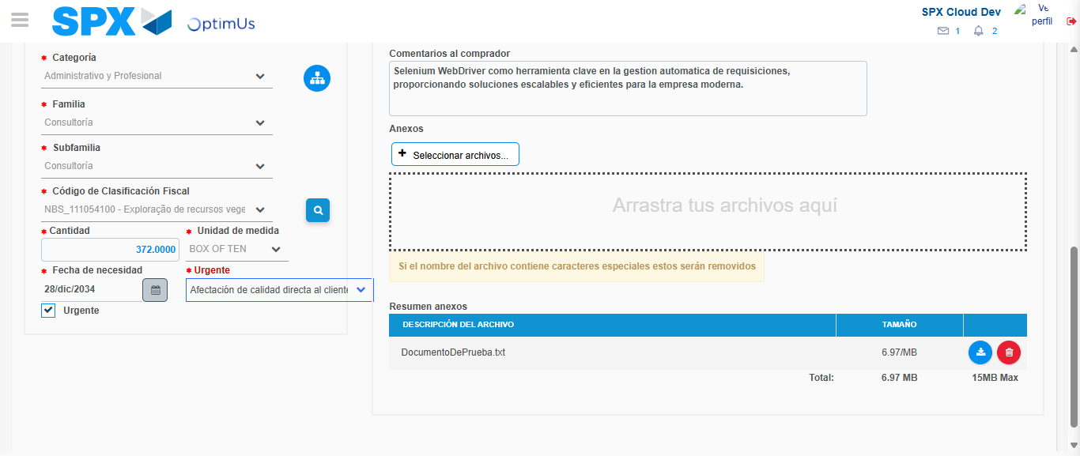Image file-name: QC_Testing-tc003_SPX_Dev5_Crear_Requisicion_Spot_Tipo_Cobro_CC_Urgent-1785961593133

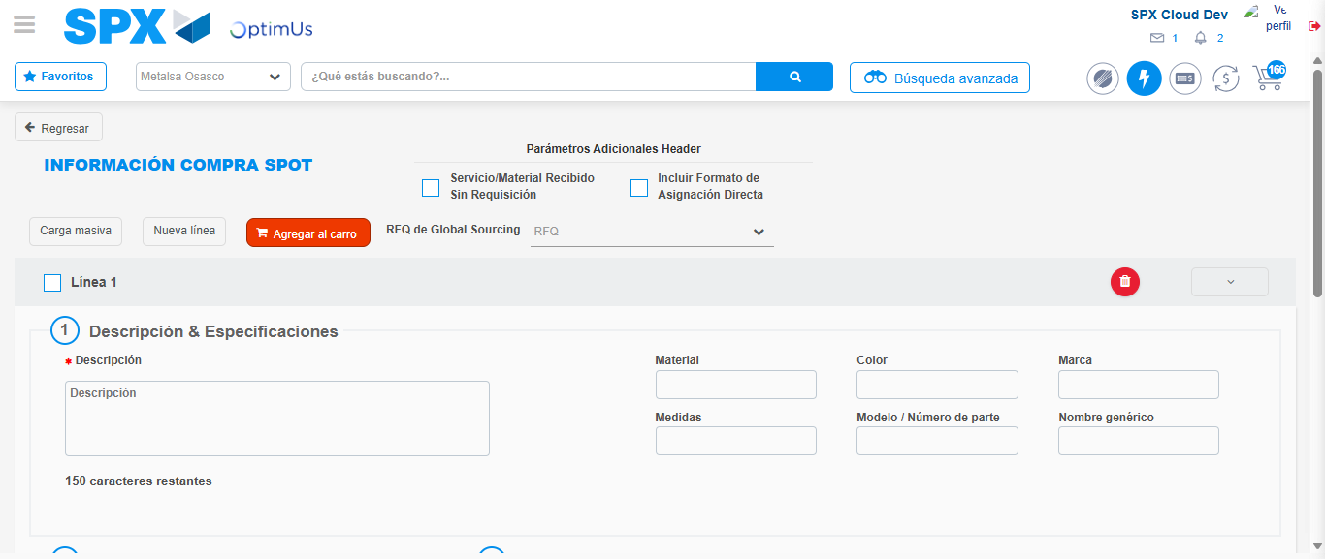Image file-name: QC_Testing-tc003_SPX_Dev5_Crear_Requisicion_Spot_Tipo_Cobro_CC_Urgent-1785961600094

Step 7 - Return to Main Page SPX : Return to Main Page SPX
Image file-name: QC_Testing-tc003_SPX_Dev5_Crear_Requisicion_Spot_Tipo_Cobro_CC_Urgent-1785961565786

Image file-name: QC_Testing-tc003_SPX_Dev5_Crear_Requisicion_Spot_Tipo_Cobro_CC_Urgent-1785961568392

Image file-name: QC_Testing-tc003_SPX_Dev5_Crear_Requisicion_Spot_Tipo_Cobro_CC_Urgent-1785961572564

Image file-name: QC_Testing-tc003_SPX_Dev5_Crear_Requisicion_Spot_Tipo_Cobro_CC_Urgent-1785961602329

Image file-name: QC_Testing-tc003_SPX_Dev5_Crear_Requisicion_Spot_Tipo_Cobro_CC_Urgent-1785961602488

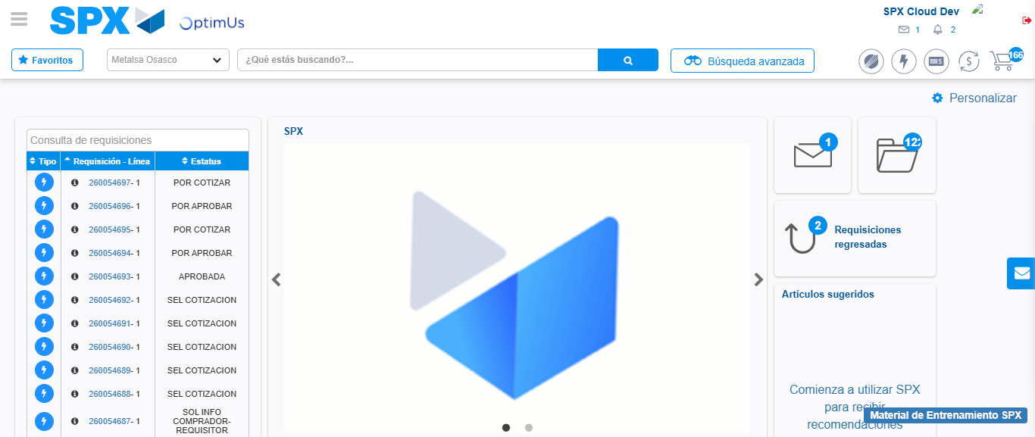Image file-name: QC_Testing-tc003_SPX_Dev5_Crear_Requisicion_Spot_Tipo_Cobro_CC_Urgent-1785961623455

Step 8 - Log Out : Log Out SPX
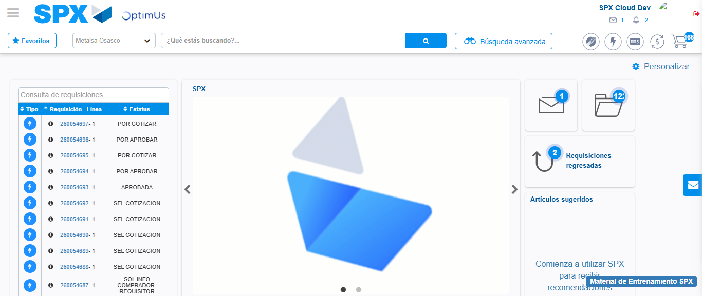Image file-name: QC_Testing-tc003_SPX_Dev5_Crear_Requisicion_Spot_Tipo_Cobro_CC_Urgent-1785961623773

